|  |  |  |  |  |
| --- | --- | --- | --- | --- |
|  |  | | |  |
|  |  | | |  |
|  | Drive Control Optimization | | |  |
|  | (MyFeatureId) | | |  |
|  |  | | |  |
|  |  | | |  |
| Document Type | **Feature Document (PD)** | | |  |
| Template Version | **4.2** | | |  |
| Document ID | **document1** | | |  |
| Document Location |  | | |  |
| Document Owner | **Lucian Vacarescu / Hua Lin** | | |  |
| Document Revision | **A** | | |  |
| Document Status | **Draft** | | |  |
| Date Issued | **2021-01-26** | | |  |
| Date Revised | **yyyy-mm-dd** | | |  |
| Document Classification | GIS1 Item Number: |  | |  |
| GIS2 Classification: | **Confidential** | |
|  | | | | |
|  | | | | |
| Document Approval | | | | |
| Person | Role | | Email Confirmation | Date |
|  |  | |  |  |
|  |  | |  |  |

Printed Copies Are Uncontrolled

# Disclaimer

**This document contains Ford Motor Company Confidential information. Disclosure of the information contained in any portion of this document is not permitted without the expressed, written consent of a duly authorized representative of Ford Motor Company, Dearborn, Michigan, U.S.A.**

**Copyright, Ó 2016 Ford Motor Company**

This document contains information developed and accumulated by and for FORD MOTOR COMPANY. As such, it is a proprietary document, which, if disseminated to unauthorized persons, would provide others with restricted information, data, or procedures not otherwise available, exposing the FORD MOTOR COMPANY to potential harm.

Employees and suppliers having custody of this specification or authorized to use it must be cognizant of its proprietary nature and ensure that the information herein is not made available to unauthorized persons.

FORD MOTOR COMPANY reserves the right to protect this work as an unpublished copyrighted work in the event of an inadvertent or deliberate unauthorized publication. FORD MOTOR COMPANY also reserves its rights under copyright laws to protect this work as a published work.

This document or portions thereof shall not be distributed outside FORD MOTOR COMPANY without prior written consent. Refer all questions concerning disclosure to the author(s) or to any duly authorized representative of Ford Motor Company.

# Contents

Disclaimer 2

Contents 3

1 Introduction 5

1.1 Feature Purpose 5

1.2 Feature Team 5

1.3 Target Vehicle Programs (initial) 6

1.4 Feature Prototype Plan 6

2 Feature Overview 7

2.1 Conceptual Basis for Feature 7

2.2 Goals 8

2.3 High Level E2E Block Diagram (optional) 8

3 Feature SCOPINg 9

3.1 Use Case 1 9

3.1.1 User Input 9

3.1.2 Output to User 9

3.1.3 Functionality of the Feature (Behavior) 9

3.1.4 Functional Interfaces 9

3.2 Use Case 2 10

3.2.1 User Input 10

3.2.2 Output to User 10

3.2.3 Functionality of the Feature (Behavior) 10

3.2.4 Functional Interfaces 10

3.3 Use Case 3 11

3.3.1 User Input 11

3.3.2 Output to User 11

3.3.3 Functionality of the Feature (Behavior) 11

3.3.4 Functional Interfaces 11

3.4 Use Case 4 12

3.4.1 User Input 12

3.4.2 Output to User 12

3.4.3 Functionality of the Feature (Behavior) 12

3.4.4 Functional Interfaces 12

3.5 Use Case 5 13

3.5.1 User Input 13

3.5.2 Output to User 13

3.5.3 Functionality of the Feature (Behavior) 13

3.5.4 Functional Interfaces 13

3.6 Use Case 6 14

3.6.1 User Input 14

3.6.2 Output to User 14

3.6.3 Functionality of the Feature (Behavior) 14

3.6.4 Functional Interfaces 14

3.7 Use Case 7 15

3.7.1 User Input 15

3.7.2 Output to User 15

3.7.3 Functionality of the Feature (Behavior) 15

3.7.4 Functional Interfaces 15

3.8 Use Case 8 16

3.8.1 User Input 16

3.8.2 Output to User 16

3.8.3 Functionality of the Feature (Behavior) 16

3.8.4 Functional Interfaces 16

3.9 Use Case 9 17

3.9.1 User Input 17

3.9.2 Output to User 17

3.9.3 Functionality of the Feature (Behavior) 17

3.9.4 Functional Interfaces 17

3.10 Use Case 10 17

3.10.1 User Input 18

3.10.2 Output to User 18

3.10.3 Functionality of the Feature (Behavior) 18

3.10.4 Functional Interfaces 18

3.11 Use Case 11 18

3.11.1 User Input 19

3.11.2 Output to User 19

3.11.3 Functionality of the Feature (Behavior) 19

3.11.4 Functional Interfaces 19

3.12 Use Case 12 19

3.12.1 User Input 19

3.12.2 Output to User 20

3.12.3 Functionality of the Feature (Behavior) 20

3.12.4 Functional Interfaces 20

3.13 Use Case 13 20

3.13.1 User Input 20

3.13.2 Output to User 21

3.13.3 Functionality of the Feature (Behavior) 21

3.13.4 Functional Interfaces 21

3.14 Use Case 14 21

3.14.1 User Input 21

3.14.2 Output to User 22

3.14.3 Functionality of the Feature (Behavior) 22

3.14.4 Functional Interfaces 22

3.15 Use Case 15 22

3.15.1 User Input 22

3.15.2 Output to User 23

3.15.3 Functionality of the Feature (Behavior) 23

3.15.4 Functional Interfaces 23

3.16 Use Case 16 23

3.16.1 User Input 23

3.16.2 Output to User 23

3.16.3 Functionality of the Feature (Behavior) 24

3.16.4 Functional Interfaces 24

4 Potential Constraints (Optional) 25

4.1 Existing Components 25

4.2 Off the Shelf Technologies 25

4.3 Undeveloped/Co-developed Dependencies 25

5 Block Diagram (Boundary/Context) 26

5.1 Potential Impacted features 26

6 Feature Resource Estimate 28

7 Key risks and Open Concerns 29

8 Revision History 30

# Introduction

**This document is intended to capture the high-level concept of a new feature. There should be enough detail for preliminary evaluation by the feature owner, SEFIRST, and architecture teams.**

**It should not contain engineering requirements or design decisions.**

## Feature Purpose

**Short description of proposed feature.**

The purpose of this feature is to leverage advanced vehicle technologies to deliver a human-centered-design optimized approach to vehicle start, shutdown, and exit. The cornerstone of this experience is the reduction, simplification, and integration of various vehicle controls inherited from traditional Internal Combustion Engine (ICE) vehicle, in order to reduce the number of superfluous customer decisions and interactions needed to operate a Battery Electric Vehicle (BEV).

Removal of ‘ON’ from Push-to-start(PTS) button – Buttonless Start feature. Allows the customer to enter the vehicle and drive away without using PTS button. Trigger of ‘ON’ is door open/brake pedal, PRNDL activation, etc. (equivalent of IGN ON status). ‘Off’ is no change.

Redefinition may be required for features due to changing triggers of IGN ON/OFF.

## Feature Team

A contact list of contributors to the content of this document - who to contact for clarification.

|  |  |  |  |
| --- | --- | --- | --- |
| **CDSID** | **Name** | **Role** | **Reference** |
| vmuttine | Venkateshwar Rao Muttineni | Pre-Feature Owner |  |
|  | Hrecznyj, Michael | Pre-Feature Owner |  |
| chende63 | Christopher Henderson | Supervisor |  |
|  | Patrick Brautigan | CIED |  |
|  | Jennifer Prescott | CIED |  |
|  | George Vrampus | Powertrain Controls |  |
|  | David Treharne | Powertrain Controls |  |
|  | Reace Head | Buttonless Start FO |  |
|  | Paul Braithwaite | Powertrain-Vehicle Starting Systems |  |
|  | Jeff Tumavitch | TDE (Shifter) |  |
|  | Zyskowski, Mark | TDE SME |  |
|  | Nichols, Jim | TDE Core |  |
|  | Farhan Ehsan | NFC |  |
|  | Victor Gonzalez | PaaK |  |
|  | John Popovecz | BCM Software |  |
|  | Kenneth Mchugh | Brake Controls Engineering |  |
|  | Jeffrey, Hamel | PaaK (FO) |  |
|  | Patricia, Seashore | BUN Owner |  |
| Lvacares | Vacarescu, Lucian | DCO Feature Owner |  |
| Hlin48 | Lin, Hua | DCO Feature Owner |  |
| Lfuller2 | Waszczenko, Lisa | DCO FO Supervisor |  |

Table 1: Contributors to this PD

## Target Vehicle Programs (initial)

Global (migration) integration plan drafted for this proposed feature.

|  |  |  |
| --- | --- | --- |
| **Program** | **Date** | **Note** |
| 24MY CDX746/747 |  |  |
|  |  |  |

Table 2: Potential Program List

## Feature Prototype Plan

No prototype

Assess need for prototype

Prototype planned

# Feature Overview

## Conceptual Basis for Feature

**Insert planning tool visual used to develop concept, such as Journey Wheel, Moments That Matter, etc.**

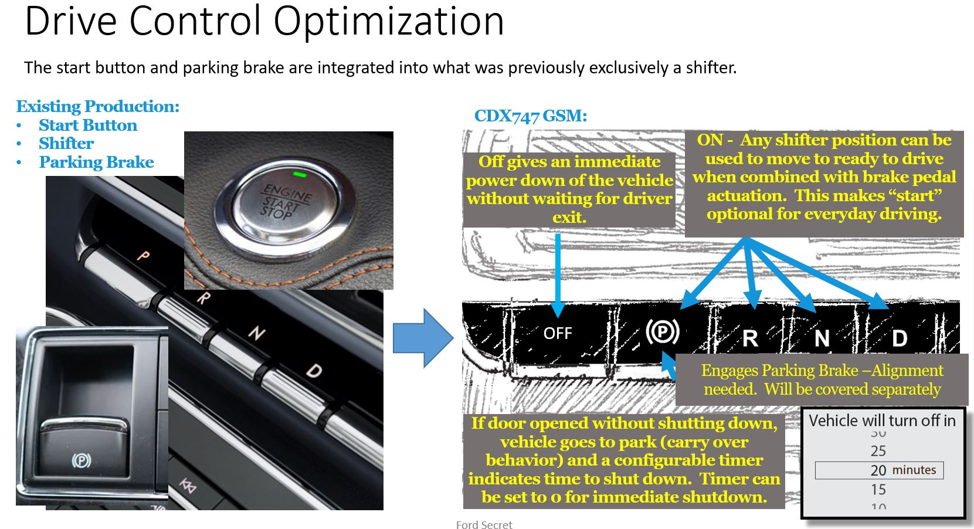



**Vision is a high level statement that aligns the feature to the standard Ford Customer Journey Wheel Moment That Matters (shown above). This is the connection of the feature to the aspiration that Ford Motor Company has in creating loyalty and excitement while providing quality and overall value for its consumers, while continuously strengthening our own foundations. If there is a market opportunity or problem that this proposal solves, include it here. If there is a clear customer or brand, note it here (i.e. CX727 or P702 BEV).**

The core idea for this concept is the customer’s ability to simply get into their vehicle, select the direction of travel, and go. Likewise, on vehicle shutdown and exit, the user need only select “park” and exit the vehicle in most use-cases. This streamlined approach provides a more elegant, tech-forward, vehicle experience.

This Reduces unneeded complexity of the vehicle entry and exit experience, that would otherwise be carried over from ICE vehicles. Support delivery of modern vehicle interior aesthetics

## Goals

**Goals here are a finer level of detail than the vision. Goals should align with the ways that the consumer, Ford, or any other actors recognize value as a result of the feature implementation. These may be strategic or tactical; but should always include a measurable outcome to be achieved. If KPIs (key performance indicators) are known, they should be explained here (for all applicable channels).**

**The goals should articulate the “winning proposition” of the feature, and may be divided into two categories: the first category identifies the minimum viable product, while the second identifies discriminators that increase the competitive advantage and should be included if time and budget allow, or protected for future inclusion.**

**Minimum Viable Product (*Must Haves* to support initial launch… cannot launch without these)**

|  |  |
| --- | --- |
| # | Goals |
|  | Goal of this feature is to improve driver entry/exit experience that include: |
| 1 | Integration of the Electronic Park Brake (EPB) switch with “park” switch of the E- Shifter |
| 2 | Eliminate Push to start switch and adding a dedicated “OFF” switch that shuts down the vehicle. |
| 3 | Re-mapping vehicle triggers to “start” the vehicle with key detection and driver’s door open and “shut down” with key device exit and driver’s door closure. |
| 4 | Allowing the user to shift out of “park” with application of the brake pedal and selection of a drive range. |
| 5 | Allowing the driver to shut down the vehicle using OFF button without waiting for driver exit. |
| 6 | Vehicle to initiate shut down sequence once the driver shifts to park and exit the vehicle with key (Key FOB, NFC Device) |
| 7 | Allowing the driver to configure delayed shutdown timer after selecting “park” and before exiting vehicle. |
|  |  |

**Nice To Haves (or… later phases shall include…)**

|  |  |
| --- | --- |
| # | Goals |
|  |  |
|  |  |
|  |  |
|  |  |

## High Level Block Diagram

**Insert diagrams, drawings or sketches that help explain the desired capability or behavior of the feature.**

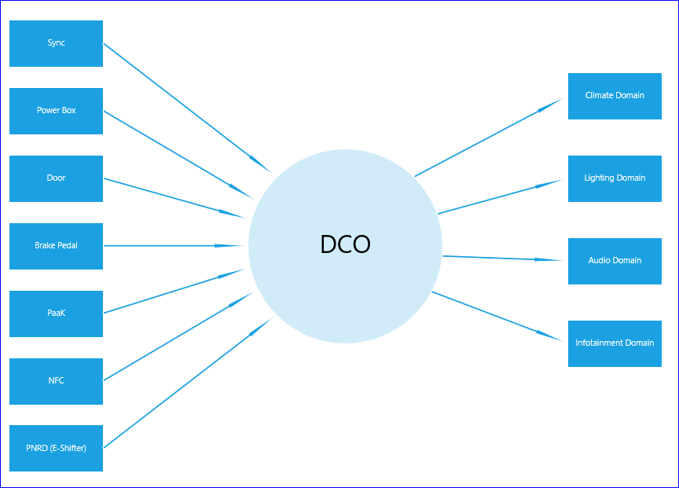

# Feature SCOPINg

**Describe the functionality of the feature in terms of Use Cases. Section 3.1 is provided for the first Use Case. Duplicate for each additional Use Case (i.e. 3.2 Use Case 2; 3.3 Use Case 3, etc.)**

## Use Case 1

**Describe one way a user will use the feature. Start with “As a user, I want to…” to list the goal of what the user wants to achieve in this use case. All sections should be addressed.**

As a user, I want to access the locked vehicle driver’s door using far-field-communication “key”(PaaK).

### User Input

**Describe the way in which a (each) user makes their intention known to the feature.**

|  |  |
| --- | --- |
| # | User Inputs |
| 1 | User approaches closer to the vehicle with far-field-communication entry ‘key’ and attempts to access the locked driver’s door vehicle. |
| 2 | Door activation switch must be applied. |
| 3  … |  |

### Output to User

**Describe the way in which a feature meets the user(s) intention.**

|  |  |
| --- | --- |
| # | User Outputs |
| 1 | User gets the access(Lock & Unlock) to the vehicle and the vehicle loads the profile associated with the key, |
| 2 | Lock/Unlock system give normal feedback. |
| 3  4  5 | Ambient lighting give normal feedback.  Welcome/Farewell (HMI, screen etc.) give feedback.  1st / 2nd seat position moving, steeling wheel moving, PPP active, |

### Functionality of the Feature (Behavior)

**Describe the way in which a feature transforms user input into output to user. Include behavior model (state diagram, sequence diagram, etc.) if available.**

|  |  |  |
| --- | --- | --- |
| # | Functions | Description |
| 1 | Key Proximity | User approaches closer to the vehicle with PaaK |
| 2 | Key Authentication | User attempts to press the button on the handle |
| 3  … | Vehicle Access | User gets access(Lock/Unlock) to the vehicle and vehicle loads the profile associated with the key. |

### Functional Interfaces

**Describe the non-user information and interactions the feature will require to achieve the user intention.**

|  |  |
| --- | --- |
| # | Functional Interfaces |
| 1 | Vehicle to be capable of supporting PaaK |
| 2 | Vehicle to be equipped with configurable Personal Profile portability |
| 3  … |  |
|  |  |
|  |  |

## Use Case 2

**Describe one way a user will use the feature. Start with “As a user, I want to…” to list the goal of what the user wants to achieve in this use case. All sections should be addressed.**

As a user, I transitions vehicle into a motive mode (power pack torque fully active) with authorized far-field-communication key (cover passive entry, passive start, not cover NFC).

### User Input

**Describe the way in which a (each) user makes their intention known to the feature.**

|  |  |
| --- | --- |
| # | User Inputs |
| 1 | Authorized far-field-communication key detected. |
| 2 | Press brake pedal. |
| 3  … |  |

### Output to User

**Describe the way in which a feature meets the user(s) intention.**

|  |  |
| --- | --- |
| # | User Outputs |
| 1 | Vehicle status become a motive mode (power pack torque fully active). |
| 2 | Chime system triggered |
| 3  4  5 | Seat belt reminder  Driver user interface in instrument cluster |

### Functionality of the Feature (Behavior)

**Describe the way in which a feature transforms user input into output to user. Include behavior model (state diagram, sequence diagram, etc.) if available.**

|  |  |  |
| --- | --- | --- |
| # | Functions | Description |
| 1 | Brake pedal status | Press brake pedal to trigger key detection |
| 2 | Key Detection | Searches for far-field-communication Key within vehicle |
| 3 | Vehicle Status | If the Key detection =True, then vehicle status become a motive mode |
| 4 |  |  |

### Functional Interfaces

**Describe the non-user information and interactions the feature will require to achieve the user intention.**

|  |  |
| --- | --- |
| # | Functional Interfaces |
| 1 | Vehicle equipped with switch detection for brake pedal status |
| 2 | Vehicle equipped with Passive start key detection antennas. |
| 3  … |  |
|  |  |

## Use Case 3

**Describe one way a user will use the feature. Start with “As a user, I want to…” to list the goal of what the user wants to achieve in this use case. All sections should be addressed.**

As a user, I enter vehicle through any doors except driver’s door with an authorized far-field-communication “key”

### User Input

**Describe the way in which a (each) user makes their intention known to the feature.**

|  |  |
| --- | --- |
| # | User Inputs |
| 1 | User unlock vehicle in case doors locked. |
| 2 | User enter vehicle through any doors except driver’s door with an authorized far-field-communication “key” |
| 3  … |  |

### Output to User

**Describe the way in which a feature meets the user(s) intention.**

|  |  |
| --- | --- |
| # | User Outputs |
| 1 | Doors unlock |
| 2 | Chime system triggered.(*to be confirmed by Chime system FO*) |
| 3  … | Welcome/Farewell triggered. |

### Functionality of the Feature (Behavior)

**Describe the way in which a feature transforms user input into output to user. Include behavior model (state diagram, sequence diagram, etc.) if available.**

|  |  |  |
| --- | --- | --- |
| # | Functions | Description |
| 1 | Door Ajar | Vehicle track door ajar status to trigger welcome/farewell feature. |
| 2 |  |  |
| 3  … |  |  |

### Functional Interfaces

**Describe the non-user information and interactions the feature will require to achieve the user intention.**

|  |  |
| --- | --- |
| # | Functional Interfaces |
| 1 | Vehicle detect far-field-communication key to unlock doors. |
| 2 |  |
| 3  … |  |
|  |  |

## Use Case 4

**Describe one way a user will use the feature. Start with “As a user, I want to…” to list the goal of what the user wants to achieve in this use case. All sections should be addressed.**

As a user, I turn vehicle on manually with an authorized far-field-communication “key”.

### User Input

**Describe the way in which a (each) user makes their intention known to the feature.**

|  |  |
| --- | --- |
| # | User Inputs |
| 1 | Press push-to-start button or Sync power button, or the brake pedal |
| 2 |  |
| 3  … |  |

### Output to User

**Describe the way in which a feature meets the user(s) intention.**

|  |  |
| --- | --- |
| # | User Outputs |
| 1 | All display ON. |
| 2 | Chime system triggered. |
| 3  … | HV Contactors close |

### Functionality of the Feature (Behavior)

**Describe the way in which a feature transforms user input into output to user. Include behavior model (state diagram, sequence diagram, etc.) if available.**

|  |  |  |
| --- | --- | --- |
| # | Functions | Description |
| 1 | Key detection | Authorized far-field-communication “key” detected. |
| 2 | Brake pedal switch status | Detect brake pedal switch status. |
| 3  4 | Chime system  HV Contactors status | Chime system triggered.  HV Contactors close if brake pedal switch ON or Sync swtich and push to start buttons ON. Vehicle tranisition status from off state to “secure idle” state. |

### Functional Interfaces

**Describe the non-user information and interactions the feature will require to achieve the user intention.**

|  |  |
| --- | --- |
| # | Functional Interfaces |
| 1 | Vehicle equipped with key detection. |
| 2 | Vehicle equipped with brake pedal switch detection. |
| 3  … | Vehcile can change transition status from off state to “secure idle” state. |
|  |  |

## Use Case 5

**Describe one way a user will use the feature. Start with “As a user, I want to…” to list the goal of what the user wants to achieve in this use case. All sections should be addressed.**

As a user, I use an authorized NFC “key” to unlock and start vehicle within authorization time window.

### User Input

**Describe the way in which a (each) user makes their intention known to the feature.**

|  |  |
| --- | --- |
| # | User Inputs |
| 1 | User scan authorized NFC key to unlock doors. |
| 2 | User start vehicle within authorization time window by pressing brake pedal, or Sync power button, or push-to-start button. |
| 3  … |  |

### Output to User

**Describe the way in which a feature meets the user(s) intention.**

|  |  |
| --- | --- |
| # | User Outputs |
| 1 | Vehicle initiates the power ON sequence |
| 2 | Chime system triggered |
| 3  … |  |

### Functionality of the Feature (Behavior)

**Describe the way in which a feature transforms user input into output to user. Include behavior model (state diagram, sequence diagram, etc.) if available.**

|  |  |  |
| --- | --- | --- |
| # | Functions | Description |
| 1 | Vehicle access | User scan authorized NFC key outside of vehicle. |
| 2 | Switch activation | Detect push-to-start button, Sync power button, brake pedal |
| 3 | Vehicle status | Vehicle to initiate power on sequence if switch activation within authorization time window |
| 4 |  |  |
| 5 |  |  |

### Functional Interfaces

**Describe the non-user information and interactions the feature will require to achieve the user intention.**

|  |  |
| --- | --- |
| # | Functional Interfaces |
| 1 | User to have NFC based device |
| 2 | User to be equipped NFC scanner outside/inside vehicle |
| 3  4 | Switch activation system detect push-to-start button, Sync power button, brake pedal etc |
| 5 |  |
|  |  |

## Use Case 6

**Describe one way a user will use the feature. Start with “As a user, I want to…” to list the goal of what the user wants to achieve in this use case. All sections should be addressed.**

As a user, I use an authorized NFC “key” to unlock and start vehicle after authorization time window by scanning NFC key within vehicle again.

### User Input

**Describe the way in which a (each) user makes their intention known to the feature.**

|  |  |
| --- | --- |
| # | User Inputs |
| 1 | User scan authorized NFC key to unlock doors. |
| 2 | User scan NFC key within vehicle again to start vehicle after authorization time window by pressing brake pedal, or Sync power button, or push-to-start button. |
| 3  … |  |

### Output to User

**Describe the way in which a feature meets the user(s) intention.**

|  |  |
| --- | --- |
| # | User Outputs |
| 1 | Vehicle initiates the power ON sequence |
| 2 | Chime system triggered |
| 3  … |  |

### Functionality of the Feature (Behavior)

**Describe the way in which a feature transforms user input into output to user. Include behavior model (state diagram, sequence diagram, etc.) if available.**

|  |  |  |
| --- | --- | --- |
| # | Functions | Description |
| 1 | Vehicle access | User scan authorized NFC key outside of vehicle. |
| 2  3 | Switch activation  Rescan NFC key | Detect push-to-start button, Sync power button, brake pedal  Rescan NFC key within vehicle if switch activation after authorization time window. |
| 4 | Vehicle status | Vehicle to initiate power on sequence . |
|  |  |  |
|  |  |  |

### Functional Interfaces

**Describe the non-user information and interactions the feature will require to achieve the user intention.**

|  |  |
| --- | --- |
| # | Functional Interfaces |
| 1 | User to have NFC based device |
| 2 | User to be equipped NFC scanner outside/inside vehicle |
| 3  … | Switch activation system detect push-to-start button, Sync power button, brake pedal etc |
|  |  |

## Use Case 7

**Describe one way a user will use the feature. Start with “As a user, I want to…” to list the goal of what the user wants to achieve in this use case. All sections should be addressed.**

As a user, I use an authorized NFC “key” to unlock vehicle.

### User Input

**Describe the way in which a (each) user makes their intention known to the feature.**

|  |  |
| --- | --- |
| # | User Inputs |
| 1 | User scan authorized NFC key to unlock doors. |
| 2 |  |
| 3  … |  |

### Output to User

**Describe the way in which a feature meets the user(s) intention.**

|  |  |
| --- | --- |
| # | User Outputs |
| 1 | User gets access (Lock/Unlock) to the vehicle |
| 2 |  |
| 3  … |  |

### Functionality of the Feature (Behavior)

**Describe the way in which a feature transforms user input into output to user. Include behavior model (state diagram, sequence diagram, etc.) if available.**

|  |  |  |
| --- | --- | --- |
| # | Functions | Description |
| 1 | NFC | User places the NFC deviceto scan within 5 cm of the NFC reader |
| 2 |  |  |
| 3  … |  |  |

### Functional Interfaces

**Describe the non-user information and interactions the feature will require to achieve the user intention.**

|  |  |
| --- | --- |
| # | Functional Interfaces |
| 1 | User to have NFC based device |
| 2 | Vehicle to be equipped with scanner outside |
| 3 |  |
| 4  … |  |
|  |  |
|  |  |

## Use Case 8

**Describe one way a user will use the feature. Start with “As a user, I want to…” to list the goal of what the user wants to achieve in this use case. All sections should be addressed.**

As a user, I enter unlocked vehicle and start vehicle using authorized NFC key.

### User Input

**Describe the way in which a (each) user makes their intention known to the feature.**

|  |  |
| --- | --- |
| # | User Inputs |
| 1 | User enter vehicle without scanning NFC key outside of vehicle |
| 2 | User scan NFC key within vehicle again to start vehicle after authorization time window by pressing brake pedal, or Sync power button, or push-to-start button. |
| 3  … |  |

### Output to User

**Describe the way in which a feature meets the user(s) intention.**

|  |  |
| --- | --- |
| # | User Outputs |
| 1 | Vehicle initiates the power ON sequence |
| 2 | Chime system triggered |
| 3  … |  |

### Functionality of the Feature (Behavior)

**Describe the way in which a feature transforms user input into output to user. Include behavior model (state diagram, sequence diagram, etc.) if available.**

|  |  |  |
| --- | --- | --- |
| # | Functions | Description |
| 1 | Vehicle access | User enter vehicle without scanning NFC key outside of vehicle |
| 2 | Switch activation | Detect push-to-start button, Sync power button, brake pedal. |
| 3 | Vehicle status | Vehicle to initiate power on sequence if switch activation is within authorization time window. |
| 4 |  |  |
| 5 |  |  |

### Functional Interfaces

**Describe the non-user information and interactions the feature will require to achieve the user intention.**

|  |  |
| --- | --- |
| # | Functional Interfaces |
| 1 | User to be equipped with NFC based device and NFC scanner inside vehicle |
| 2 | Switch activation system detect push-to-start button, Sync power button, brake pedal etc |
| 3  … |  |
|  |  |

## Use Case 9

**Describe one way a user will use the feature. Start with “As a user, I want to…” to list the goal of what the user wants to achieve in this use case. All sections should be addressed.**

As a user, I exit vehicle through driver’s door with authorized “key”. (automatic shutdown)

### User Input

**Describe the way in which a (each) user makes their intention known to the feature.**

|  |  |
| --- | --- |
| # | User Inputs |
| 1 | Driver exit vehicle with authorized “key” |
| 2 | Driver’s door position from open to close. |
| 3  … |  |

### Output to User

**Describe the way in which a feature meets the user(s) intention.**

|  |  |
| --- | --- |
| # | User Outputs |
| 1 | Vehicle initiate shutdown sequence. (confirmed by Paul Braithwaite) |
| 2 | Welcome/Farewell triggered by signals.(confirmed by Welcome/Farewell FO) |
| 3  … | Chime System triggered by signals.(to be confirmed by Chime system FO) |

### Functionality of the Feature (Behavior)

**Describe the way in which a feature transforms user input into output to user. Include behavior model (state diagram, sequence diagram, etc.) if available.**

|  |  |  |
| --- | --- | --- |
| # | Functions | Description |
| 1 | Vehicle status | Vehicle to initiate power off sequence. Powertrain deactived, HV Contactor transition to open. |
| 2 |  |  |
| 3 |  |  |
| 4 |  |  |
| 5 |  |  |

### Functional Interfaces

**Describe the non-user information and interactions the feature will require to achieve the user intention.**

|  |  |
| --- | --- |
| # | Functional Interfaces |
| 1 | User to be equipped with authorized “key”. |
| 2 | Vehicle capable with “key” detection and door ajar switch to initiate automatic shutdown. |
| 3  4 |  |
| 5 |  |
|  |  |

## Use Case 10

**Describe one way a user will use the feature. Start with “As a user, I want to…” to list the goal of what the user wants to achieve in this use case. All sections should be addressed.**

As a user, I shut vehicle down through push-to-start on/off button.(manual shutdown). Precondition is vehicle speed is less than 5Kph.

### User Input

**Describe the way in which a (each) user makes their intention known to the feature.**

|  |  |
| --- | --- |
| # | User Inputs |
| 1 | Press vehicle power button. |
| 2 |  |
| 3  … |  |

### Output to User

**Describe the way in which a feature meets the user(s) intention.**

|  |  |
| --- | --- |
| # | User Outputs |
| 1 | Vehicle go to “park” position, initate shutdown sequence, HV contactor transition to open. |
| 2 | Chime System triggered by signals. (carry over behavior) |
| 3  … | Vehicle in delay accessary mode until driver’s door is open (to be confirmed) |

### Functionality of the Feature (Behavior)

**Describe the way in which a feature transforms user input into output to user. Include behavior model (state diagram, sequence diagram, etc.) if available.**

|  |  |  |
| --- | --- | --- |
| # | Functions | Description |
| 1 | Switch status | User press vehicle power button and vehicle speed is less than 5kph. |
| 2 | Vehicle status | Vehicle go to “park” position and initiate power off sequence. Powertrain deactived, HV Contactor transition to open. |
| 3 | Vehicle mode | Vehicle is in delay accessary mode until driver’s door open. |
| 4 |  |  |
| 5 |  |  |

### Functional Interfaces

**Describe the non-user information and interactions the feature will require to achieve the user intention.**

|  |  |
| --- | --- |
| # | Functional Interfaces |
| 1 | Vehicle to be equipped with ON/OFF switch. |
| 2 | Vehicle to be equipped with speed sensors. |
| 3  4 | Vehicle to be equipped with door ajar switch. |
| 5 |  |
|  |  |

## Use Case 11

**Describe one way a user will use the feature. Start with “As a user, I want to…” to list the goal of what the user wants to achieve in this use case. All sections should be addressed.**

As a user, I deactivate powertrain through push-to-start on/off button(manual shutdown) if vehicle speed is more than 5Kph.

### User Input

**Describe the way in which a (each) user makes their intention known to the feature.**

|  |  |
| --- | --- |
| # | User Inputs |
| 1 | Press vehicle power button. |
| 2 |  |
| 3  … |  |

### Output to User

**Describe the way in which a feature meets the user(s) intention.**

|  |  |
| --- | --- |
| # | User Outputs |
| 1 | Vehicle shift to neutral and powertrain is deactived to prevent accident. |
| 2 | Steering, braking, cluster functions operate normally. |
| 3  … |  |

### Functionality of the Feature (Behavior)

**Describe the way in which a feature transforms user input into output to user. Include behavior model (state diagram, sequence diagram, etc.) if available.**

|  |  |  |
| --- | --- | --- |
| # | Functions | Description |
| 1 | Switch status | User press vehicle power button and vehicle speed is more than 5kph. |
| 2 | Powertrain status | Vehicle shift to neutral and powertrain is deactivated with Steering, braking, cluster functions operate normally. |
| 3 |  |  |
| 4 |  |  |
| 5 |  |  |

### Functional Interfaces

**Describe the non-user information and interactions the feature will require to achieve the user intention.**

|  |  |
| --- | --- |
| # | Functional Interfaces |
| 1 | Vehicle to be equipped with ON/OFF switch. |
| 2 | Vehicle to be equipped with speed sensors. |
| 3  4 | Vehicle to be equipped with EPAS and EBB (Electrical Power Assist Steering and Electrical Brake Booster) and capable to work without powertrain. |
| 5 |  |
|  |  |

## Use Case 12

**Describe one way a user will use the feature. Start with “As a user, I want to…” to list the goal of what the user wants to achieve in this use case. All sections should be addressed.**

As a user, I re-activate powertrain by selecting a drive range through E-Shifter. Pre-condition is user deactivate powertrain through push-to-start on/off button(manual shutdown) and vehicle speed is more than 5Kph.

### User Input

**Describe the way in which a (each) user makes their intention known to the feature.**

|  |  |
| --- | --- |
| # | User Inputs |
| 1 | Select a drive range through E-Shifter. (Drive or reverse gear) |
| 2 |  |
| 3  … |  |

### Output to User

**Describe the way in which a feature meets the user(s) intention.**

|  |  |
| --- | --- |
| # | User Outputs |
| 1 | Powertrain re-activated. Vehicle move based on E-Shifter selections. |
| 2 |  |
| 3  … |  |

### Functionality of the Feature (Behavior)

**Describe the way in which a feature transforms user input into output to user. Include behavior model (state diagram, sequence diagram, etc.) if available.**

|  |  |  |
| --- | --- | --- |
| # | Functions | Description |
| 1 | Switch status | User press vehicle power button and vehicle speed is more than 5kph. |
| 2 | Powertrain de-activation | Vehicle shift to neutral and powertrain is deactivated with Steering, braking, cluster functions operate normally. |
| 3 | Drive range selection | User select drive range from E-Shifter (drive or reverse gear) |
| 4 | Powertrain re-activation | Powertrain re-activated. Vehicle move based on E-Shifter selections. |
| 5 |  |  |

### Functional Interfaces

**Describe the non-user information and interactions the feature will require to achieve the user intention.**

|  |  |
| --- | --- |
| # | Functional Interfaces |
| 1 | Vehicle to be equipped with ON/OFF switch. |
| 2 | Vehicle to be equipped with speed sensors. |
| 3 | Vehicle to be equipped with EPAS and EBB (Electrical Power Assist Steering and Electrical Brake Booster) and capable to work without powertrain. |
| 4 | Vehicle capable shifting drive range without foot on brake pedal |
|  |  |

## Use Case 13

**Describe one way a user will use the feature. Start with “As a user, I want to…” to list the goal of what the user wants to achieve in this use case. All sections should be addressed.**

As a user, I would not want vehicle to shutdown while I remain in vehicle with authorized “key” and vehicle is in “park”. Pre-condition is that active AEIS and HV battery is above low SoC (State of Charge) threshold.

### User Input

**Describe the way in which a (each) user makes their intention known to the feature.**

|  |  |
| --- | --- |
| # | User Inputs |
| 1 | User inside vehicle with authorized “key” |
| 2 | Input from user (press brake pedal, re-configuration AEIS through HMI, acceleration pedal) detected within 30 minutes from the last activity detection inside vehicle. |
| 3  … | Vehicle is in “park”. |

### Output to User

**Describe the way in which a feature meets the user(s) intention.**

|  |  |
| --- | --- |
| # | User Outputs |
| 1 | Vehicle continue idling until AEIS timer limitation exceeded. |
| 2 | Shutdown sequence alert 30 seconds before AEIS timer expiration. |
| 3  … |  |

### Functionality of the Feature (Behavior)

**Describe the way in which a feature transforms user input into output to user. Include behavior model (state diagram, sequence diagram, etc.) if available.**

|  |  |  |
| --- | --- | --- |
| # | Functions | Description |
| 1 | HV battery status | HV battery is above low SoC (State of Charge) threshold. |
| 2 | Key status | Key detection within vehicle |
| 3 | Vehicle status | Vehicle is in “park” (park by brake). |
| 4 | AEIS status | AEIS active. |
| 5  6 | User input  Alert status | press brake pedal, re-configuration AEIS through HMI, acceleration pedal within AEIS timer limitation, these inputs reset AEIS timer to last configured time.  Chime or/and display alert for initiating shutdown sequence 30 seconds before AEIS timer limitation expiration. |

### Functional Interfaces

**Describe the non-user information and interactions the feature will require to achieve the user intention.**

|  |  |
| --- | --- |
| # | Functional Interfaces |
| 1 | Vehicle equipped with HV battery status monitoring system |
| 2 | HV battery status monitoring system capable to communicate to BCM to trigger shutdown sequence if low charge state detected. |
| 3  4 | Vehicle equipped with user configurable of AEIS  Vehicle equipped with “key” (far-field-communication key) detection device |
| 5 |  |
|  |  |

## Use Case 14

**Describe one way a user will use the feature. Start with “As a user, I want to…” to list the goal of what the user wants to achieve in this use case. All sections should be addressed.**

As a user, I can configure vehicle automatic idel shutdown timer while vehicle is in “park”.

### User Input

**Describe the way in which a (each) user makes their intention known to the feature.**

|  |  |
| --- | --- |
| # | User Inputs |
| 1 | Vehicle is in “park”. |
| 2 | User to interact with HMI to configure AEIS timer. |
| 3  … | ~~Seat belt is off.~~ |

### Output to User

**Describe the way in which a feature meets the user(s) intention.**

|  |  |
| --- | --- |
| # | User Outputs |
| 1 | AEIS timer is configured by user selection. |
| 2 |  |
| 3  … |  |

### Functionality of the Feature (Behavior)

**Describe the way in which a feature transforms user input into output to user. Include behavior model (state diagram, sequence diagram, etc.) if available.**

|  |  |  |
| --- | --- | --- |
| # | Functions | Description |
| 1 | HMI | HMI to offer AEIS menu to the user |
| 2 | AEIS Timer status | User configures / deactivate AEIS timer |
| 3 |  |  |
| 4 |  |  |
| 5 |  |  |

### Functional Interfaces

**Describe the non-user information and interactions the feature will require to achieve the user intention.**

|  |  |
| --- | --- |
| # | Functional Interfaces |
| 1 | Vehicle HMI to be equipped with AEIS menu |
| 2 | Vehicle to be equipped with AEIS configurable by user |
| 3  4 |  |
| 5 |  |
|  |  |

## Use Case 15

**Describe one way a user will use the feature. Start with “As a user, I want to…” to list the goal of what the user wants to achieve in this use case. All sections should be addressed.**

As a user, I alter AEIS idle timer using FordPass/Lincoln Way Device. Pre-condition is that user select to delay shutdown with AEIS HMI.

### User Input

**Describe the way in which a (each) user makes their intention known to the feature.**

|  |  |
| --- | --- |
| # | User Inputs |
| 1 | User select to delay vehicle shutdown with AEIS HMI before exiting the vehicle. |
| 2 | User alter AEIS idle timer through FordPass/Lincoln Way Device. |
| 3  … |  |

### Output to User

**Describe the way in which a feature meets the user(s) intention.**

|  |  |
| --- | --- |
| # | User Outputs |
| 1 | AEIS idle timer is selected by user through FordPass/Lincoln Way Device. |
| 2 |  |
| 3  … |  |

### Functionality of the Feature (Behavior)

**Describe the way in which a feature transforms user input into output to user. Include behavior model (state diagram, sequence diagram, etc.) if available.**

|  |  |  |
| --- | --- | --- |
| # | Functions | Description |
| 1 | HMI | HMI to offer AEIS menu to the user |
| 2 | AEIS Timer status | User configures / deactivate AEIS timer |
| 3 |  |  |
| 4 |  |  |
| 5 |  |  |

### Functional Interfaces

**Describe the non-user information and interactions the feature will require to achieve the user intention.**

|  |  |
| --- | --- |
| # | Functional Interfaces |
| 1 | Vehicle HMI to be equipped with AEIS menu |
| 2 | Vehicle to be equipped with AEIS configurable by user |
| 3  4 | Vehicle to be equipped with authorized FordPass/Lincoln Way Device  Vehicle to be equipped with FordPass/Lincoln Way Device authorization |
| 5 |  |
|  |  |

## Use Case 16

**Describe one way a user will use the feature. Start with “As a user, I want to…” to list the goal of what the user wants to achieve in this use case. All sections should be addressed.**

As a user, I enter vehicle through keypad on the driver’s door.

### User Input

**Describe the way in which a (each) user makes their intention known to the feature.**

|  |  |
| --- | --- |
| # | User Inputs |
| 1 | User input access code through keypad on the driver’s door. |
| 2 |  |
| 3  … |  |

### Output to User

**Describe the way in which a feature meets the user(s) intention.**

|  |  |
| --- | --- |
| # | User Outputs |
| 1 | User gets the access(Lock & Unlock) to the vehicle. |
| 2 | Lock/Unlock system give normal feedback. |
| 3  4  5 | Ambient lighting give normal feedback.  Welcome/Farewell (HMI, screen etc.) give feedback.  1st / 2nd seat position moving, steeling wheel moving, PPP active, |

### Functionality of the Feature (Behavior)

**Describe the way in which a feature transforms user input into output to user. Include behavior model (state diagram, sequence diagram, etc.) if available.**

|  |  |  |  |  |  |  |
| --- | --- | --- | --- | --- | --- | --- |
| # | Functions | | | | Description | |
| 1 |  | | Key Authentication | User attempts to press the keypad on the driver’s door | |
| 2 |  | Vehicle Access | | User gets access(Lock/Unlock) to the vehicle. | |
| 3 |  |  | |  | |
|  |  | | | |  | |
|  |  | | | |  | |

### Functional Interfaces

**Describe the non-user information and interactions the feature will require to achieve the user intention.**

|  |  |
| --- | --- |
| # | Functional Interfaces |
| 1 | Vehicle equipped with keypad on the driver’s door |
| 2 |  |
| 3  4 |  |
| 5 |  |
|  |  |

# Potential Constraints (Optional)

Subject to Architectural team review.

## Existing Components

Describe the way in which existing components could be modified to implement the feature.

Add rational statement that ties to Section 3.

## Off the Shelf Technologies

Describe existing technology that could be employed to implement the feature.

Add rational statement that ties to Section 3.

## Undeveloped/Co-developed Dependencies

Describe anything that must be developed along with this feature. (Like if it requires URC, how is that impacting other features and when will it be done?).

# Block Diagram (Boundary/Context)

Diagram how the feature could fit within existing functional and physical design.

Add rational statement that ties to Section 3.

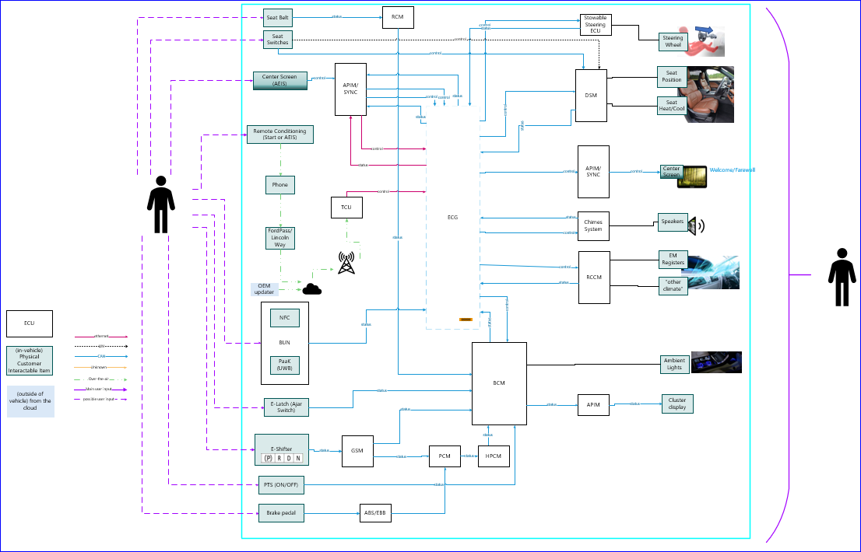

## Potential Impacted features

|  |  |  |
| --- | --- | --- |
| **Feature** | **Stakeholder** | **Note** |
| Personal Portable Profile (PPP) | Justin Bauer (J.) |  |
| Phone as a Key (PaaK) | Victor Gonzalez |  |
| Rejuvenate | Matthew Harkless (M.S.) |  |
| Stowable steering wheel/tray table | Richard John, Tok Lau |  |
| Starting feature (PTS) | David (dtreharn@ford.com) |  |
| Welcome/Farewell | Darnell Fuller |  |
| Sentinel | Ishan Gupta |  |
| Register Aim (EM registers) | George Smith (G.) |  |
| Classic Memory (PPP) | Evangelos Foutis (E.) |  |
| Enhanced Memory (PPP) | Walter Stephens (W.L.) |  |
| Ambient Lighting | Ralph Gemade (R.) |  |
| Remote Park Assist | Markus Krekel (Z.Z.) |  |
| First Row Seat Position Control | Diana Aguilar |  |
| Seat Temperature | Joel Beckmeyer |  |
| MyKey (PaaK) | Sumeet Inamdar (S.) |  |
| Remote Start | Sally Cherian (S.) |  |
| Unlock Purge / Periodic Parking Purge | Joe Strozeski |  |
| E-Shifter | Sri Marepally |  |
| Guard Mode | Ekanthappa Rudresh (R.) |  |
| Chimes System | Hugo Ayala Gonzalez (H.) |  |
| Passive Entry Passive Start (PEPS) | Frank Shmaon |  |
| AEIS | CP Engelbrecht |  |
| Locking / unlocking features | Daniel King (D.M.) |  |
| Switch Reduction Strategy | Marija Bogachuk |  |
| Buttonless Start | Reace Head |  |
| Park-by-Brake | Wiley Falconer |  |
| Ultimate Remote Control (URC) | Gregory Reed |  |
| Walk-Away Locking | Amber Mortzfield (A.M.) |  |
| NFC (Near Fields Communication) | Rita Trupiano (M.P.) |  |
| Easy Entry Easy Exit (EEEE) | Evangelos Foutis |  |
| Second Row Seat Position Control | Diana Aguilar |  |
| Climate Control |  |  |

Table 3: Potential Impacted Feature List

# Feature Resource Estimate

Estimate Feature resource (FO headcount) allocation using Feature Rubric tool.

Add link.

# Key risks and Open Concerns

**#Hint:** The following list presents open concerns, which have to be discussed or clarified over the course of the on-going requirements engineering.

| ID | Concern Description | e-Tracker / Reference | Responsible | Status | Solution |
| --- | --- | --- | --- | --- | --- |
| 1 |  |  |  |  |  |
| 2 |  |  |  |  |  |
| 3 |  |  |  |  |  |
| 4 |  |  |  |  |  |
| 5 |  |  |  |  |  |
| 6 |  |  |  |  |  |
| 7 |  |  |  |  |  |
| 8 |  |  |  |  |  |
| 9 |  |  |  |  |  |

Table 21: Open Concerns

# Revision History

| Rev.  (revision) | Date | Description | Approved by | Responsible |
| --- | --- | --- | --- | --- |
| *1.0* | *2021.02.05* | *Initial version for Feature* |  |  |
|  |  |  |  |  |
|  |  |  |  |  |

Feature Document ends here.

## Template Revisions

*#Important: Do not change this section*